**Hadoop Setup**

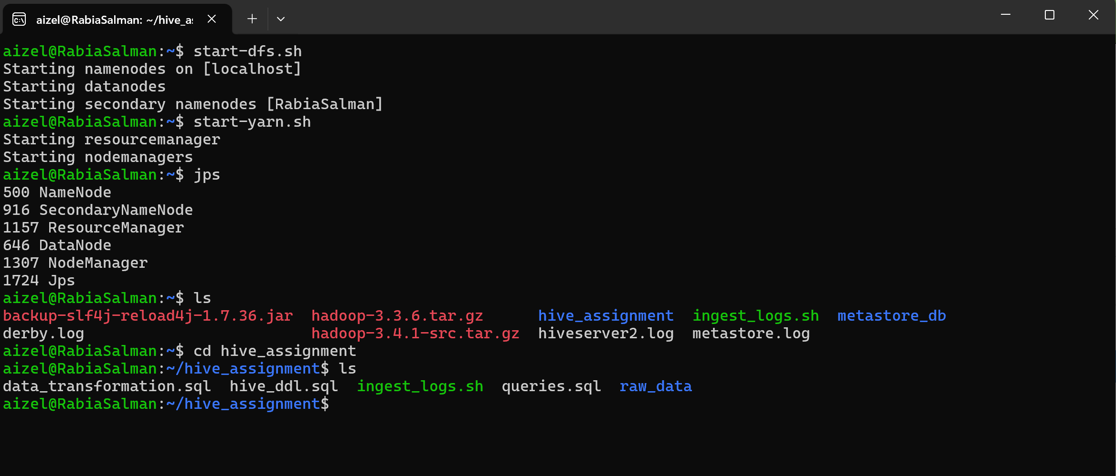

**Directories at Localhost**

**DataNode Information**

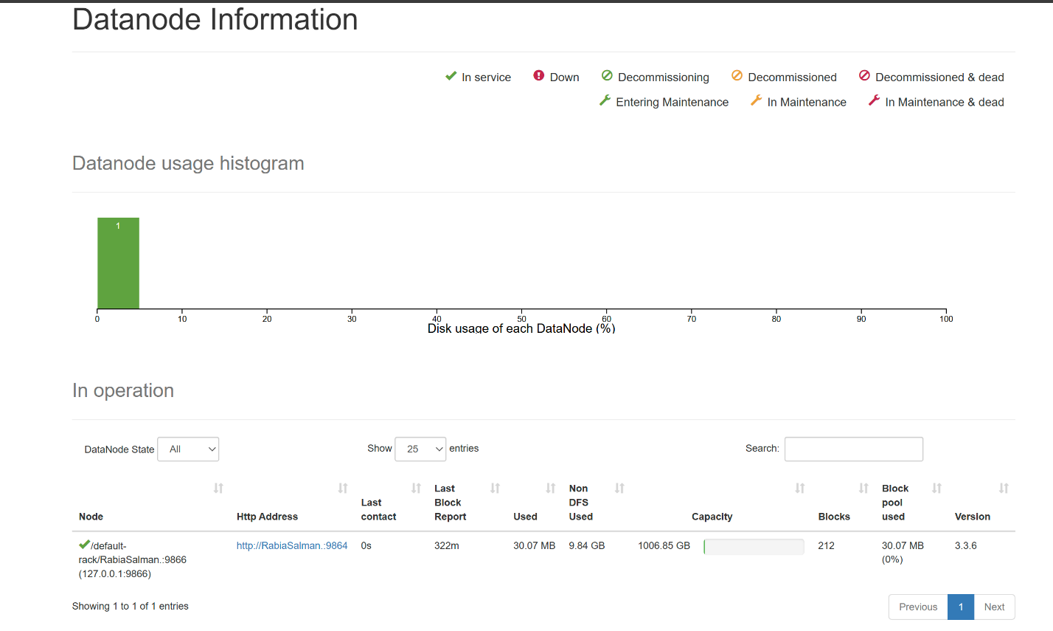

**File Information**

**Partitions in Hadoop**

**Startup Progress**

**Hive Tables**

1. **User_activity_logs**

CREATE EXTERNAL TABLE IF NOT EXISTS user_activity_logs (

user_id STRING,

action STRING,

`timestamp` STRING,

details STRING

)

PARTITIONED BY (year INT, month INT, day INT)

ROW FORMAT DELIMITED

FIELDS TERMINATED BY ','

STORED AS TEXTFILE

LOCATION 'hdfs://localhost:9000/raw/logs';

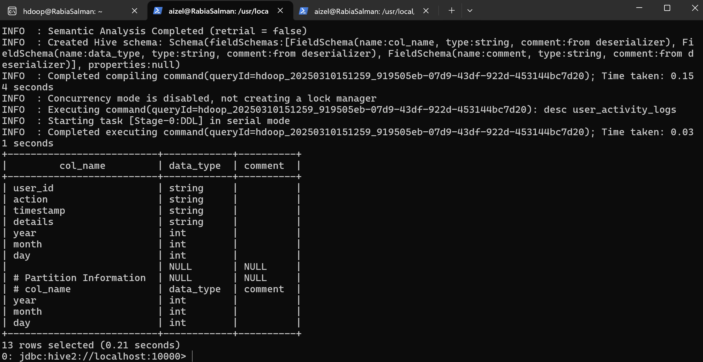

**Showing Partitions**

SHOW PARTITIONS aizel_hadoop_hive.user_activity_logs;

**Injestion Script**

**#!/bin/bash**

**# File: project-root/scripts/ingest_logs.sh**

**# Usage: ./ingest_logs.sh <YYYY-MM-DD>**

**# This script ingests user activity log CSV files into HDFS.**

**if [ "$#" -ne 1 ]; then**

**echo "Usage: $0 <YYYY-MM-DD>"**

**exit 1**

**fi**

**DATE="$1"**

**YEAR=$(echo "$DATE" | cut -d'-' -f1)**

**MONTH=$(echo "$DATE" | cut -d'-' -f2)**

**DAY=$(echo "$DATE" | cut -d'-' -f3)**

**# Local directories for logs and metadata (adjust paths as needed)**

**LOCAL_LOG_DIR="C:/Users/aizel/Downloads/LUMS OFFICIAL DATA/Data Eng/labs/data-ingestion-hive/project-root/user_activity_logs"**

**LOCAL_META_DIR="C:/Users/aizel/Downloads/LUMS OFFICIAL DATA/Data Eng/labs/data-ingestion-hive/project-root/raw_data/metadata"**

**# HDFS target directories**

**HDFS_LOG_DIR="/raw/logs/$YEAR/$MONTH/$DAY"**

**HDFS_META_DIR="/raw/metadata/$YEAR/$MONTH/$DAY"**

**# Create HDFS directories**

**hdfs dfs -mkdir -p "$HDFS_LOG_DIR"**

**hdfs dfs -mkdir -p "$HDFS_META_DIR"**

**# Ingest log file (if exists) into HDFS**

**LOG_FILE="$LOCAL_LOG_DIR/user_activity_logs_${DATE}.csv"**

**if [ -s "$LOG_FILE" ]; then**

**hdfs dfs -put "$LOG_FILE" "$HDFS_LOG_DIR/"**

**echo "Ingested logs from $LOG_FILE into $HDFS_LOG_DIR"**

**else**

**echo "Warning: Log file $LOG_FILE is empty or does not exist."**

**fi**

**# Ingest metadata file into HDFS (assuming one file for all dates)**

**META_FILE="C:/Users/aizel/Downloads/LUMS OFFICIAL DATA/Data Eng/labs/data-ingestion-hive/project-root/content_metadata.csv"**

**if [ -s "$META_FILE" ]; then**

**hdfs dfs -put "$META_FILE" "$HDFS_META_DIR/"**

**echo "Ingested metadata from $META_FILE into $HDFS_META_DIR"**

**else**

**echo "Warning: Metadata file $META_FILE is empty or does not exist."**

**fi**

**echo "Ingestion process complete."**

1. **Content_metadata**

CREATE TABLE content_metadata (

content_id INT PRIMARY KEY,

title TEXT,

category TEXT,

length INT,

artist TEXT

);

**Query: 1. Get All User Activities with Content Details**

**Query 2.**

**

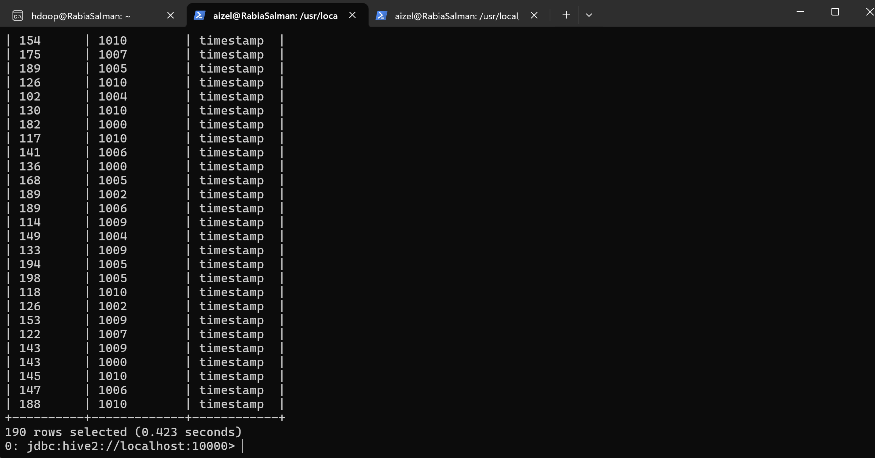

**Query 3**

**Count Actions per Month (here for month=2)**

Select day, count(*) as action_count from user_activity_logs where year=2025 and month=2 group by day;

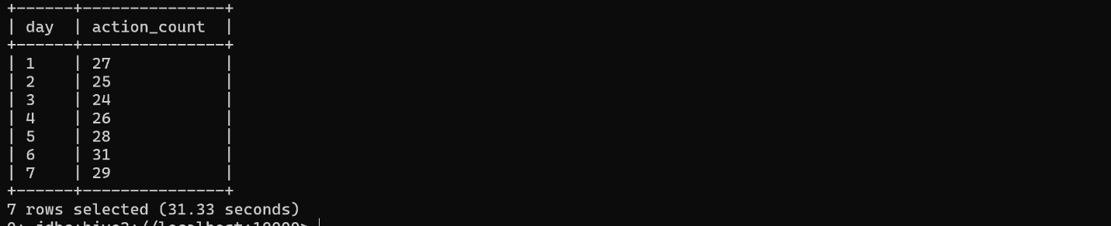

**Query Results for data injested in Content_metadata table**

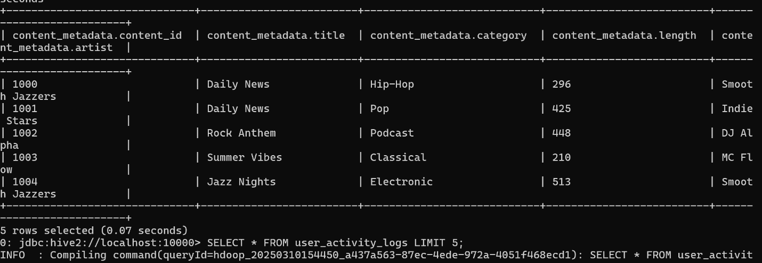

**Query Results for Limit 5 data injested in User_activity_logs table**

**Query Results for active users in second month**

**Query Count of Unique Active Users per Day**

SELECT year, month, day, COUNT(DISTINCT user_id) AS active_users

FROM user_activity_logs

GROUP BY year, month, day

ORDER BY year DESC, month DESC, day DESC;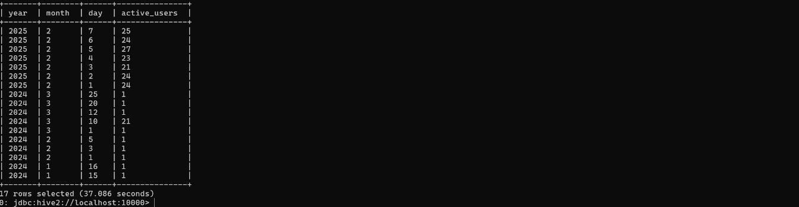

**Query Results for Top Played Content**

SELECT content_id, COUNT(*) AS play_count

FROM user_activity_logs

WHERE action = 'play'

GROUP BY content_id

ORDER BY play_count DESC

LIMIT 5;

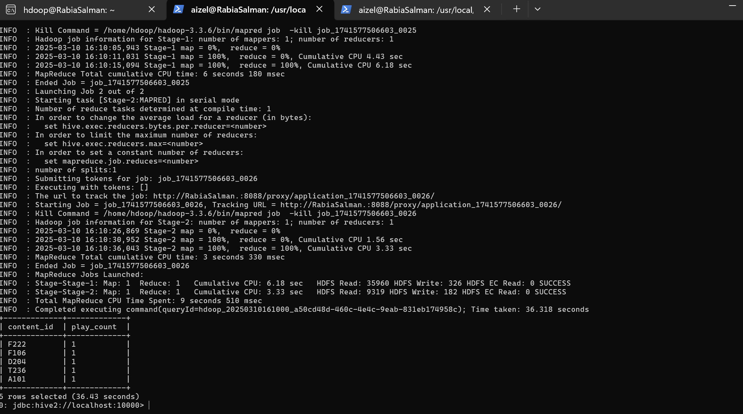

**Pause-to-Play Ratio**

**This query calculates how often users pause compared to play for a given date.**

SELECT year, month, day,

SUM(CASE WHEN action = 'pause' THEN 1 ELSE 0 END) AS pause_count,

SUM(CASE WHEN action = 'play' THEN 1 ELSE 0 END) AS play_count,

ROUND(SUM(CASE WHEN action = 'pause' THEN 1 ELSE 0 END) * 100.0 /

NULLIF(SUM(CASE WHEN action = 'play' THEN 1 ELSE 0 END), 0), 2) AS pause_to_play_ratio

FROM user_activity_logs

GROUP BY year, month, day

ORDER BY year DESC, month DESC, day DESC;

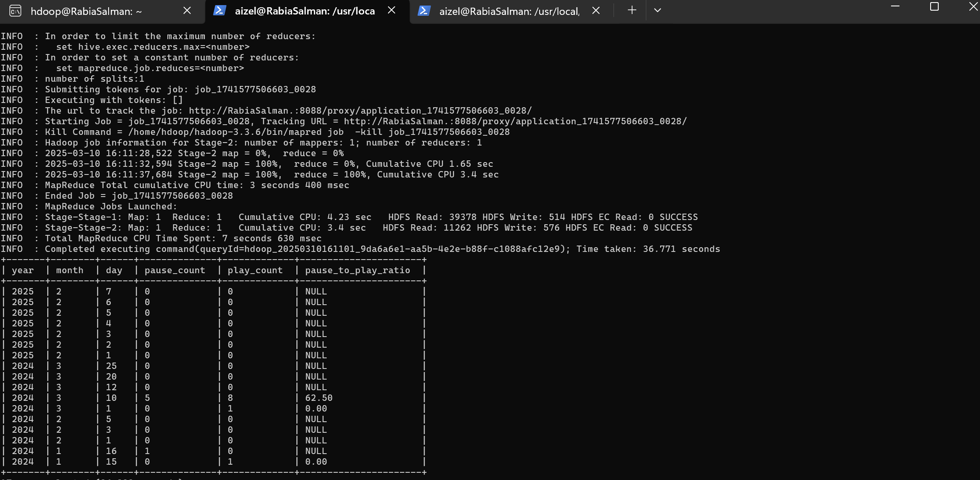

**Create the Dimension Table (dim_content)**

**This stores content metadata, which will be joined with the fact table for analysis.**

CREATE TABLE dim_content (

content_id STRING,

title STRING,

category STRING,

length INT,

artist STRING

)

STORED AS PARQUET;

**Create the Fact Table (fact_user_actions)**

**This stores user activity logs and is partitioned by year, month, and day.**

CREATE TABLE fact_user_actions (

user_id STRING,

action STRING,

timestamp STRING,

details STRING,

content_id STRING

)

PARTITIONED BY (year INT, month INT, day INT)

STORED AS PARQUET;

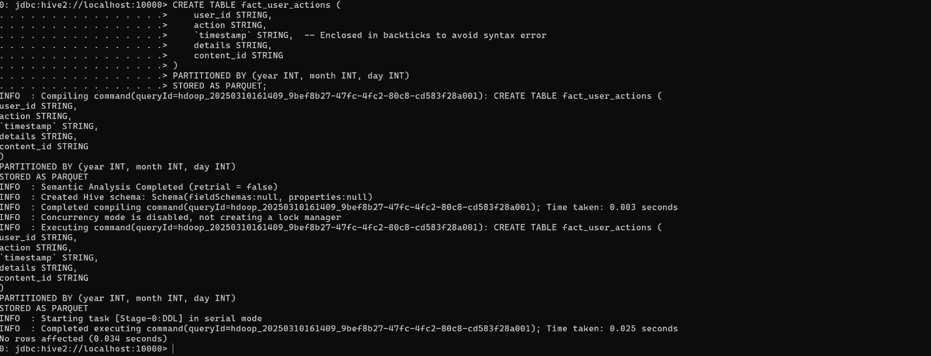

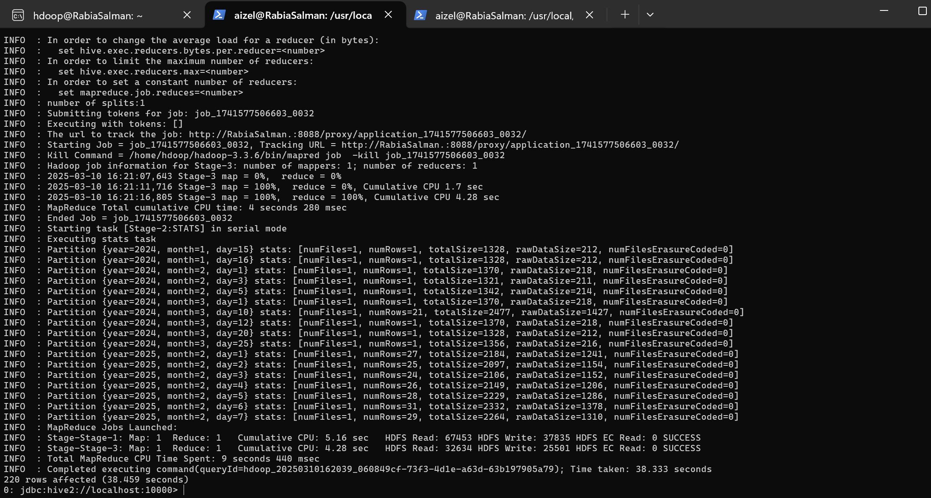

**Query: Showing data from Star Schema (Fact_user_actions)**

